Chapter 5 Notes IFT381
Open Systems Interconnection (OSI) Reference Model –
- Layer 7 – Application (UI)
- Layer 6 – Presentation (Data format, encryption)
- Layer 5 – session (process-to-process communication)
- Layer 4 – Transport (End to end communication)
- Layer 3 – Network (WAN delivery, Routing data, logical addressing, IP addressing)
- Layer 2 – Data Link (Physical addressing, Lan delivery, MAC addressing)
- Layer 1 – Physical (wires cables n stuff, Signaling)
Wide Area Networks (WAN) – large geographic area (internet)
Once data leaves network security is not guaranteed
Internet is an open network low cost but less secure
Personal WAN expensive more secure
Router – Connects a LAN to a WAN selectively interchanges packets of data between them by examining network addresses to decide where to send each packet.
- Border routers- between WAN and an internal network. Is exposed to WAN so can be attacked from the outside
- Internal Routers - Internal network routers. Keep subnet traffic separate and provide protection by keeping undesired traffic out and desired traffic in a subnet
Network Address Translation (NAT) – IP address assignment uses alternate public IP to hide a system’s actual internal IP.
IP Address – 32bit (IPv4) or 128 bit (IPv6) number uniquely identifies a device
Router/firewall filters packets
Local Area Network (LAN) – same geographic area (most likely connected by a device such as a hub or switch) LAN systems typically do not protect from one another (could require the internet which is not usually allowed) Good security on LAN is important malware infecting a LAN can spread quick
Ethernet Networks – IEEE 802.3 CSMA/CD Standard for wired networking speeds between 10Mbps-10Gbps
Switch – a LAN device, a hardware device that connects several systems to the network. Segments connect to network using a direct connection between a sending and receiving port can preform intelligent filtering
Hub - a LAN device, A legacy device that connects network segments by echoing all received traffic to all other ports basically connecting a bunch of ports together
Virtual LAN (VLAN) – Created in router and switch config setup. Collection of logically related network devices viewed as a partitioned network segment
TCP/IP (Transmission control Protocol/Internet Protocol)
Protocol – a set of rules a that govern the format of messages computers exchange
TCP/IP– suite of protocols that work on network and transport layers govern internet activity
TCP – Transport Layer Protocol
Use Datagram Protocol (UDP) – works alongside TCP at Transport Layer to support upper-level protocols.
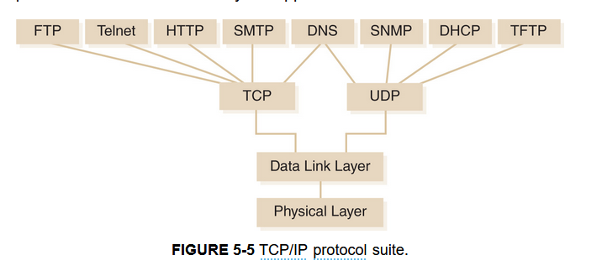
IP addressing – Network Layer protocol
IPv4 address – 4 byte (32 bit) address uniquely identifying each device on a network Not enough addresses (192.168.2.1) Allows subnet masking
Subnet – a partition of network based on IP addresses
IPv6 address – (32-35% of internet traffic as of 2021) 128 bits long more unique addresses and more security and features (0:0:0:0:0:ffff:c0a8:a01)
Dynamic Host Configuration Protocol (DHCP) – Protocol used on IP networks to automatically provide configuration details to client computers. (IPv4 address, subnet mask, essential communication info all come from network) DHCPv6 is DHCP for IPv6
Common Ports
Network port – number that tells a receiving device where to send messages
HTTP uses port 80
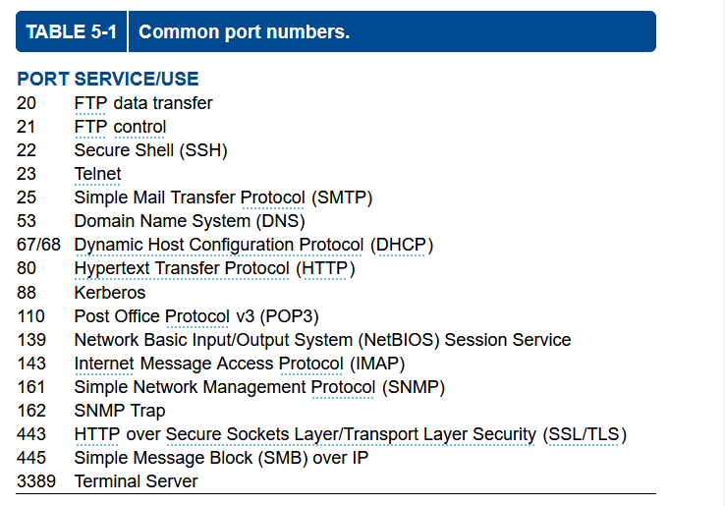
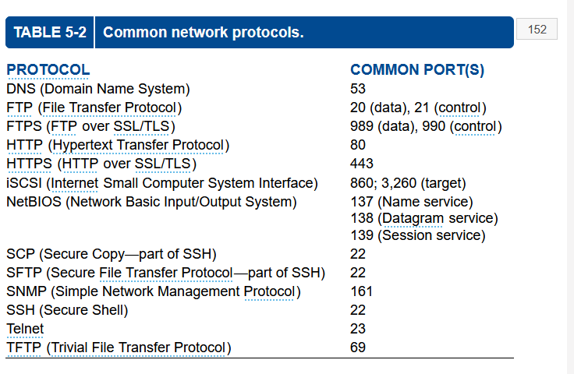
Internet Control Message Protocol (ICMP) – Management control protocol for IP networks
IMCP echo request – Sent by ping command sends ping request expects ping reply can be used to ddos

Three main categories of risk:
Reconnaissance – Gathering Information to use for a future attack
Limit IMCP echo requests from outside the network
Eavesdropping – listening in on network traffic
Limit physical access to cables
Use switched networks
Encrypt sensitive Data
Denial of Service (DoS)- attempt to shut down a network can be through flooding the network with data
DDoS – Attack from many addresses
Telephony DoS (TDoS) – Prevent telephone calls
Ensure Internet Bandwith is adequate to withstand large loads
Detect attacks as early as possible and block the incoming traffic prior to reaching network
Firewall – controls flow of traffic by preventing unauthorized network traffic from entering or leaving a network segment simple firewalls allow access control lists. Firewalls can also provide
- Flood Guard – limit traffic bandwith from hosts
- Loop Protection – Look at messaging addresses to determine if a message is being sent around an unending loop
- Network Segmentation – enforce divisions or separations between networks
Firewall Types
- Packet Filtering – Very Basic firewall. Compares received traffic with rules that define what traffic is permitted for each packet that reaches the firewall with no memory of past packets
- Stateful Inspection – Remembers information about the status of communication. When it receives first packet of communication it remembers that session until it is closed. Only checks rules when sessions starts
- Application Proxy – Packets cannot directly travel between systems on opposite sides of the firewall. Opens separate connections with both sides and acts as a broker between them.
Firewall Deployment Techniques
- Border Firewall – Separate protected network from the internet sit behind the router and receive all info passing from private network to internet and from router to private network Companies with no public services use this
- Screened Subnet – 2 “border firewall” firewalls one for private network and one for the internet. + 1 interface connected to a special network (screened subnet or demilitarized zone (DMZ)
  - DMZ – Semi private network used to host services that the public can access. Limited access from internet to private network. Mahcines are confined to DMZ
Companies with public services use this
- Multilayered Firewalls – Large and/or highly secured environments use this. Multiple firewalls segment network into pieces networks can have different security levels
- Unified Threat Management – Multi purpose firewalls provide filtering and other services such as
  - URL filter – Filter web traffic by using URL instead of Ips
  - Content Inspection – Looks at some or all of the packet content to see if it should be allowed on the network
  - Malware inspection – Specialized contrent inspection for signs of malware
Virtual Private Network (VPN) – encrypts data in transit to an organizations network. Allowing use of corporate data from home.
- Point-to-Point Tunneling Protocol (PPTP) – implements VPN connection. Usually natively supported by an OS
- Secure Sockets Layer (SSL) / Transport Layer Security (TLS) – encrypts web communications. Connect to SSL/TLS webpage login download software to connect no advanced config of the system
- Secure Socket Tunneling Protocol (SSTP) – Microsoft . Only on Windows. Easier setup more modern approach to vpns
- Internet Protocol Security (IPSec) – a suite of protocols designed to securely connect sites usually requires 3rd party software but are easily configurable on a router
- OpenVPN – opensource VPN using SSL/TLS both available in TCP and UDP varieties
Network access control (NAC) – a method to restrict access to a network based on identity or other rules. 2 major tasks, Authentication And posture checking
Posture checking can check a users configuration to see if it meets security standards (up to date antivirus active firewall, supported OS, ect.)
Either NAC can deny access to network or send them to quarantine to be fixed before access to the main network
Extensible Authentication Protocol (EAP) – Authentication framework that defines the transport of keys and authentication credentials
Wireless Access Point (WAP) – Radio Sending and receiving networking info over air between wireless devices.
MAC address filtering - Restricting access to an object based on its classification and user security clearance.
Use vpns over wireless networks
Create guest wifi with no vpn access and limited connectivity to the internal network
Encrypt wireless communications
Wired Equivalent Privacy (WEP)- Protocol uses RC4 encryption Outdated
Wi-Fi Protected Access (WPA) – 2003 strong AES encryption
SSID Broadcasting can be disabled for increased security if your network does not need to be discoverable

